CECS 225

Lab 3

Eugene Paul Mesina



* **Section 1:** ALU_Decoder Verilog module source

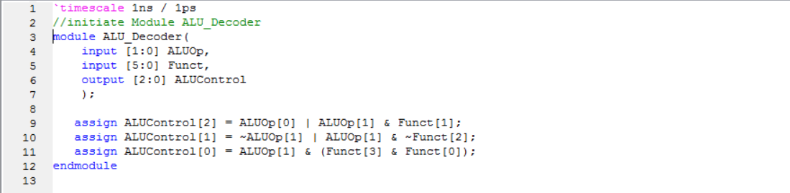

* **Section 2:** ALU_Decoder Verilog Test Fixture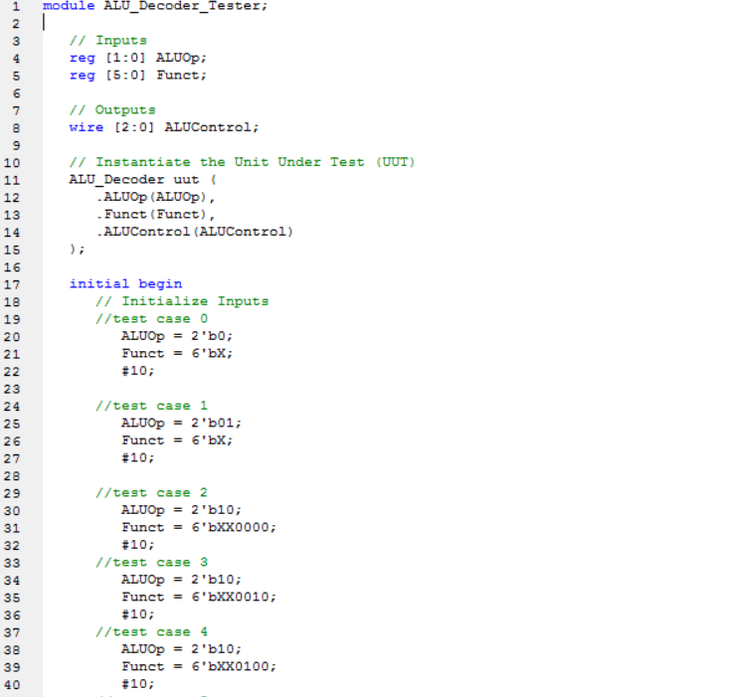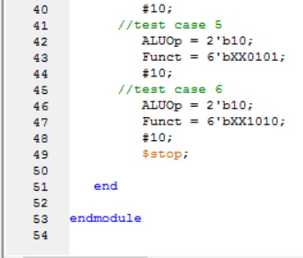
* **Section 3:** ALU_Decoder Simulation Waveform Screenshot showing correct results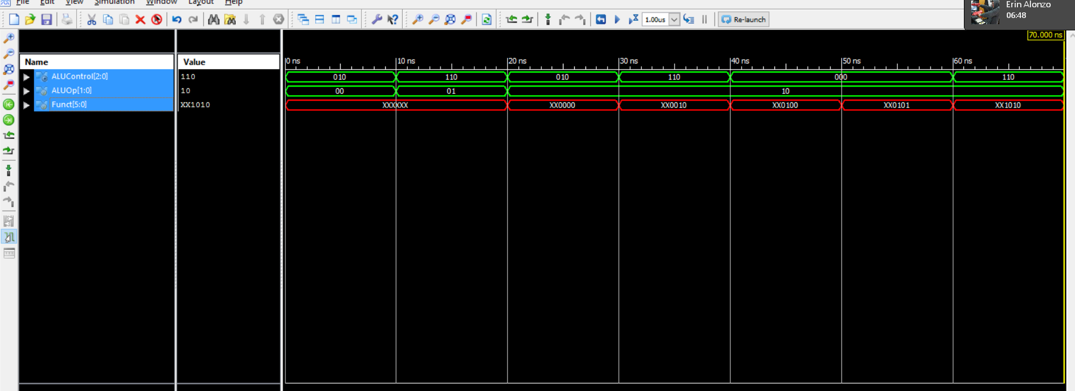
* **Section 4:** Main_Decoder Verilog module source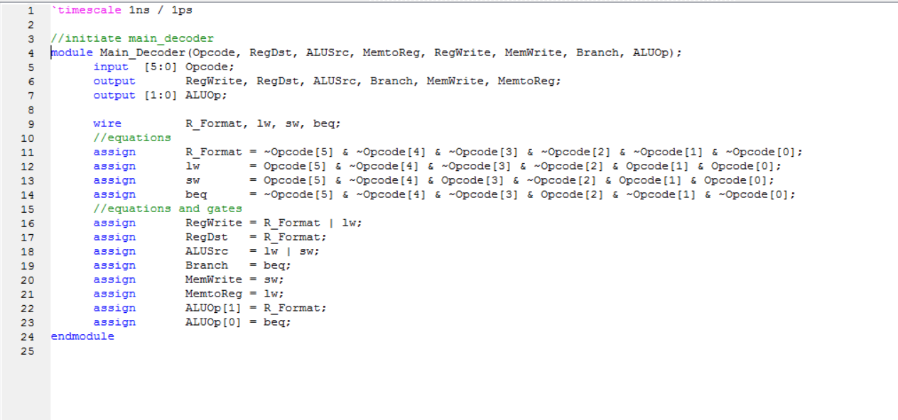
* **Section 5:** Main_Decoder Verilog Test Fixture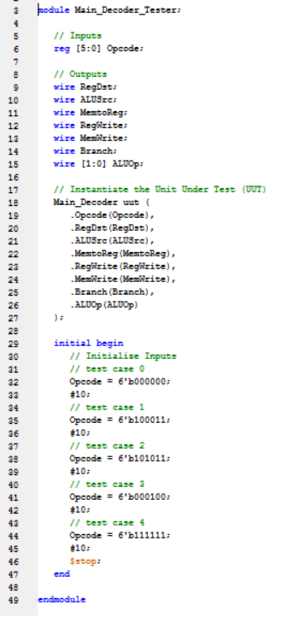
* **Section 6:** Main_Decoder Simulation Waveform Screenshot showing correct results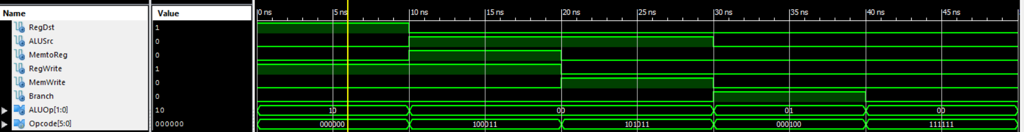
* **Section 7:** Control_Unit Verilog module source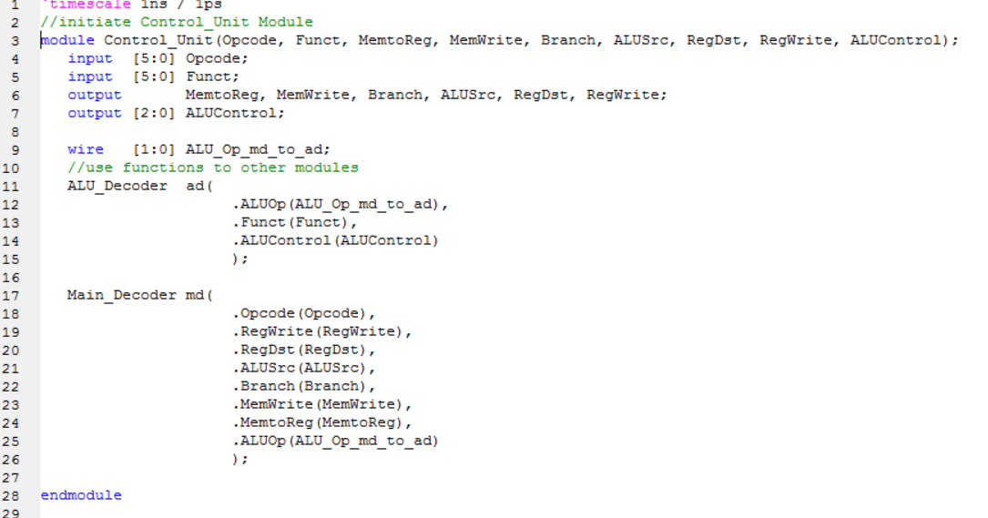
* **Section 8:** Control_Unit Verilog Test Fixture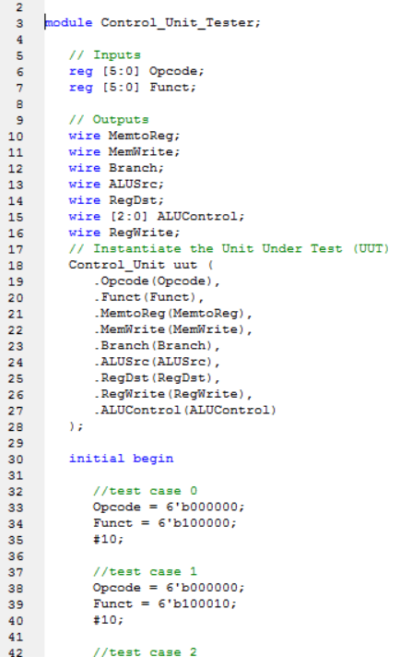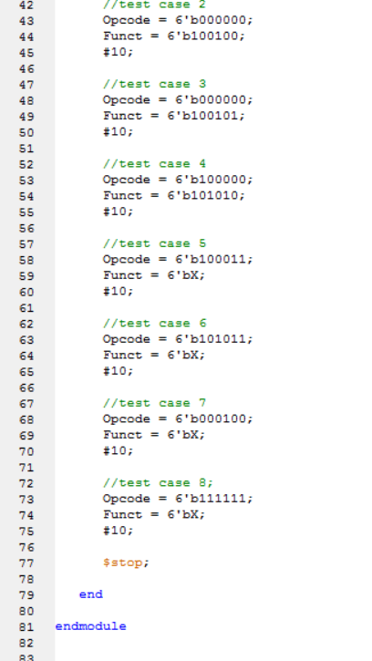
* **Section 9:** Control_Unit Simulation Waveform Screenshot showing correct results